|  |  |  |  |  |  |  |
| --- | --- | --- | --- | --- | --- | --- |
| Description: Vertical full colour positive | Safety Bay Senior High School | | | | | |
| **CHEMISTRY UNIT 3 & 4** | | | | | | |
| **Test #5:** | | | | | | |
| **Organic Chemistry** | | | | | | |
|  | | | | | | |
| **NAME:** | | | **ANSWERS** | | | |
|  | | |  | | | |
| **Time allowed for this paper** | | | | | | |
| Reading time: | | 5 minutes | | | | |
| Working time: | | 50 minutes | | | | |
|  | | | | | | |
| **Structure of this paper:** | | | | | | |
| Section | | | Number of questions | Marks available | | Marks achieved |
| Section One: Multiple Choice | | | 10 | 10 | |  |
| Section Two: Short Answer | | | 6 | 41 | |  |
|  | | |  | | **Total** | ______ / 51 |

**Section One: Multiple Choice**

Answer all questions by circling the correct option. Only circle one option for each question.

1. A student’s study notes on protein structure included these four unlabelled sketches:

|  |  |
| --- | --- |
|  | H  H  H  N  C  C  O  O  H  R |
|  | **I** |

**II**

Ala

His

Met

Ala

Pro

**III**

**IV**

|  |  |  |  |  |  |  |  |  |  |  |  |  |  |  |  |  |  |  |  |  |  |
| --- | --- | --- | --- | --- | --- | --- | --- | --- | --- | --- | --- | --- | --- | --- | --- | --- | --- | --- | --- | --- | --- |
| Which sketches best represent the primary, secondary and tertiary structure of proteins   |  |  |  |  | | --- | --- | --- | --- | |  | **Primary structure** | **Secondary structure** | **Tertiary structure** | | (a) | I | II | IV | | (b) | I | IV | II | | (c) | III | IV | II | | **(d)** | **III** | **II** | **IV** | |  |
|  |  |

1. Proteins that show a high degree of similarity in their primary structure in the Protein Data Bank are most likely to have

**(a) similar function.**

(b) identical tertiary structure.

(c) been isolated from the same species.

(d) the same amino acid composition.

1. A chemist attempts to identify a pungent, colourless liquid by conducting several experiments. The results are shown in the table below:

|  |  |
| --- | --- |
| **Experiment** | **Observations** |
| Add acidified potassium dichromate solution | Orange solution turns green |
| A lighted taper held above the liquid | Flame and heat produced |
| Add sodium metal | Metal reacts and colourless, odourless gas evolved |
| Add acidified, concentrated acetic ( ethanoic) acid | Fruity odour produced |

Using this information, identify the functional group present in the liquid.

1. ketone
2. **alcohol**
3. amine
4. carboxylic acid
5. The IUPAC systematic name for the compound whose structure is given below is
6. 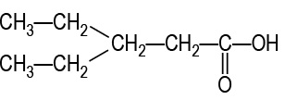3,3-diethylpropanoic acid
7. 3-ethylpentanal
8. **3-ethylpentanoic acid**
9. 1-hydroxy-3-ethylpentanone
10. A compound associated with the smell or flavour of pineapples has the following structural formula

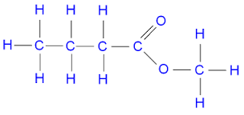

To produce this compound in the laboratory you would react:

**(a) methanol and butanoic acid in the presence of concentrated sulfuric acid.**

(b) 1-butanol and methanol in the presence of concentrated sulfuric acid.

(c) 1-butanol and methanoic acid in the presence of concentrated sulfuric acid.

(d) methanol and methanoic acid in the presence of concentrated sulfuric acid.

1. For which of the following organic molecules does the structural diagram match the correct IUPAC name given?

|  |  |  |  |  |
| --- | --- | --- | --- | --- |
| (i) |  |  | (ii) | (iii) |
|  |  |  |  |  |
| 2-methylpentan-4-one |  |  | 1,2,3-trichloropropene | aminoethanal |

a) (i) only

b) (i) and (ii) only

**c) (ii) only**

d) (ii) and (iii) only

1. Concentrated sulfuric acid is an essential ingredient of esterification. Its function is to
2. facilitate the oxidation of the alcohol to a carboxylic acid
3. energise both reactants and products
4. neutralise the basic (– OH) group of the alcohol
5. **provide the reaction with an alternative pathway that requires a lower amount of activation energy**
6. Which of these substances can be oxidised to produce propanoic acid?
7. propan-2-ol
8. propanone
9. **propanal**
10. propene
11. Which one of the following compounds is an α- amino acid?

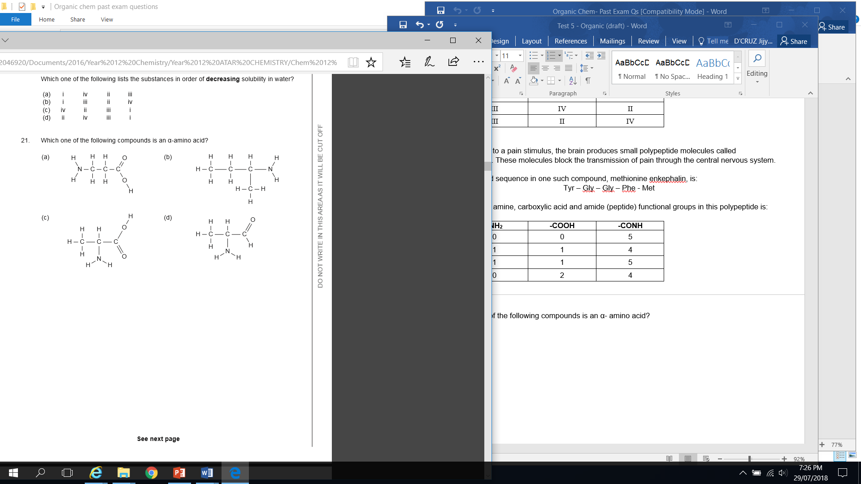

**( C)**

1. A sample of ethanoic acid was placed in a beaker and several drops of universal indicator were added. To the beaker, aqueous sodium carbonate was added dropwise until it was in excess. Which of the following statements is **not** correct regarding the reaction that would have taken place?
2. A colourless, odourless gas would have been produced.
3. The colour of the solution would have changed from pink to green to blue.
4. A neutralisation reaction would have taken place.
5. **A solid white salt would have been produced.**

**Section Two: Short Answer**

Write your answers in the spaces provided.

**Question 11** **(5 marks)**

The following screenshot shows the structure of 5EPZ, a human angiogenin protein.

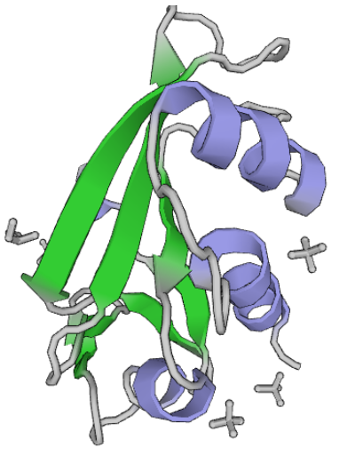

**Alpha helix**

**(or α-helix)**

**Beta-pleated sheets**

**(or β-pleated sheets)**

**OR**

1. Label the above diagram by naming the outlined features. (2 marks)

**1 mark per label. Award 0.5 each if missing alpha and beta.**

1. Explain what leads to the formation of the structures shown on the diagram above. (2 marks)

**Due to hydrogen bonding (1 mark) between the O and H atoms from different peptide groups/ amide groups (1 mark)**

1. The image above was sourced from the Protein Data Bank (PDB). Briefly describe the role of the PDB. (1 mark)

**International database of protein structures/shapes (0.5 mark) so researchers can share information / collaborate / build off of each other’s work / gain information about proteins relevant to their research* (0.5 marks)**

*\*or something similar to that effect. i.e. explaining why an international database of protein structures was created*

**Question 12** **(6 marks)**

Complete the following table:

|  |  |
| --- | --- |
| **IUPAC Name** | **Structural Formula** |
| 5-chloro-3-methylpentanal | **CH3 O**  **| ||**  **Cl-CH2-CH2-CH-CH2-C-H** |
| **butanoic acid** | CH3CH2CH2COOH |
| **butan-2-ol** |  |
| 4-chloropentan-2-one | **O Cl**  **|| |**  **CH3-C-CH2-CH-CH3** |
| propan-1-amine | **CH3-CH2-CH2-NH2** |
| **4-chloro-3-methylpentanoic acid** |  |

**Question 13** **(10 marks)**

Phenylalanine (chemical structure shown below) is an essential α-amino acid.

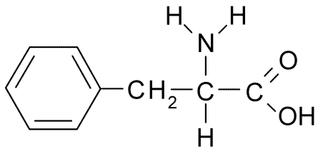

* 1. Why is phenylalanine classified as an **alpha** amino acid? (1 mark)

**The amine(/NH2) group and the carboxyl (/COOH) group are separated by a single carbon atom. (1)**

* 1. In neutral solutions at pH 7, phenylalanine exists as a zwitterion. Draw the structure of the zwitterion form of phenylalanine. (1 mark)



* 1. What evidence is there that solid phenylalanine is comprised of molecules in the zwitterion form? Explain. (3 marks)

**Very high melting point (1)**

**This indicates very strong form of bonding – stronger than hydrogen bonding of similarly sized molecules (1)**

**Can be explained through zwitterion structure. The force of attraction between molecules must be ionic bonding between opposing charges of different molecules (1)**

***Also accept other forms of evidence. e.g. crystalline appearance, brittleness***

* 1. The structure of amino acids is dependent on pH. Draw the structure of the α-amino acid **lysine** under the following pH conditions. *(Refer to your data book for the structure of lysine)* (3 marks)

|  |  |
| --- | --- |
| **pH** | **Structure of lysine** |
| 2 | **(2 marks)**  **Note: Both NH2 groups would be protonated.  Award 1 mark if students only protonated one NH2 group.** |
| 12 | **(1 mark)** |

* 1. Draw the structure of a dipeptide formed between phenylalanine and lysine. On your drawing circle and label the ‘peptide bond’. (2 marks)



***Where R chains correspond to side chains for phenylalanine and lysine.***

***Accept either order of amino acids (Phe-Lys or Lys-Phe)***

**1 mark for structure**

**1 mark for peptide bond**

**Question 14 (9 marks)**

1. Methanoic acid, HCOOH, may be produced by oxidation of an alcohol with acidified potassium permanganate, MnO4⁻, solution.

Write the oxidation and reduction half-equations and the final redox equation for this reaction.

(5 marks)



**(2)**

**(1)**

**(2)**

***State symbols not required. If oxidation and reduction are reverse award a max of 4 marks.***

***Balancing the final equation requires cancelling of H+ and H2O. Award 1 mark if not simplified.***

Candidates should be encouraged to write the condensed structural formula (e.g. CH3OH) rather than the molecular formula (e.g. CH4O).

1. Methanoic acid reacts with ethanol in the presence of sulfuric acid to produce a sweet smelling compound.

Write the balanced equation for the reaction of methanoic acid with ethanol. (2 marks)

**HCOOH + CH3CH2OH** **🡪 HCOOCH2CH3 + H2O (2) *Deduct 1 if water is missing***

Although candidates may have been able to correctly draw the structure of the ester in part (c), they were unable to write its formula in part (b).

(c) Draw the structural formula for the sweet smelling compound and give its IUPAC name. Show all

all H atoms in the structure. (2 marks)

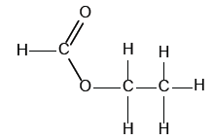

Name: **Ethyl methanoate (1)**

1mark

**Question 15 (5 marks)**

Glycerol (IUPAC name: propane-1,2,3-triol) can be used an anti-freeze due to its high water solubility. Explain, with the aid of a diagram, why glycerol has high solubility in water.

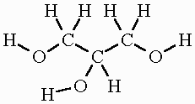

1. **Glycerol and water both have hydrogen bonding as the predominant types of intermolecular force (IMF) in the pure substance**
2. **Glycerol is able to form hydrogen bonds with water molecules**

**(2)The hydrogen bonds formed between glycerol and water molecules are similar in strength to the H bonds within each individual substance. The similarity in strength between the two interactions leads to glycerol being able to dissolve.**

1. **Diagram**



**Question 16** **(6 marks)**

Myrcene is a naturally occurring compound found in the leaves of bay trees. It is known to be a polyunsaturated hydrocarbon. It can react with hydrogen to produce a saturated hydrocarbon.

In a laboratory investigation, a 1.00 g sample of myrcene fully reacted with exactly 510 mL of hydrogen gas measured as 20.0 °C and 105.0 kPa. In this reaction, myrcene was converted to a saturated alkane with a molecular formula C10H22.

* 1. What type of reaction has occurred between the myrcene and hydrogen? (1 mark)

**Addition (1)**

* 1. Calculate the number of moles of hydrogen reacting. (1 mark)

**n(H2) = PV/RT = (105x0.510)/(8.315*293.15) = 0.0220 mol (1)**

* 1. Calculate the mass of C10H22 produced in the reaction. (2 marks)

**It is an addition reaction, so m(C10H22) = m(myrcene) + m(H2)**

**m(H2) = n x 1.008 = 0.02215 g (1 mark)**

**m(C10H22) = m(myrcene) + m(H2) = 1.00 + 0.02215 = 1.02 g (1 mark)**

* 1. Determine the number of double bonds in each molecule of myrcene. (2 marks)

**n(C10H22) = m / M = 1.02 / 142.276 = 0.00718 mol (1 mark)**

**n(myrcene) = n(C10H22) = 0.00718 mol**

**n(H2) / n(myrcene) = 0.0220 / 0.00718 = ~3**

**therefore must be 3 double bonds per molecule of myrcene (1 mark)**

*No marks for a guess of 3 with no logical substantiation*

**SPARE PAGE**